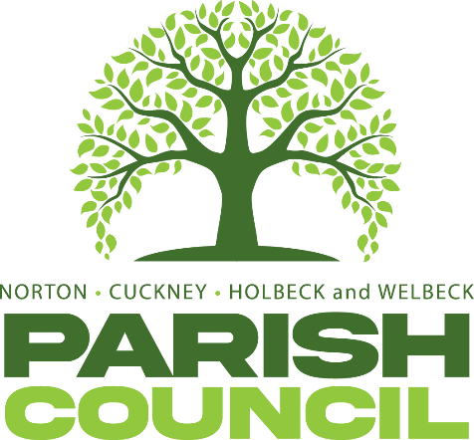

Extraordinary Parish Council Meeting
Pursuant to Schedule 12 of the Local Government Act 1972, Councillors are hereby summoned to attend at Extraordinary Parish Council Meeting of Norton, Cuckney, Holbeck, and Welbeck Parish Council to be held on Monday, 27th July 2026, at Norton & Cuckney Village Hall at 7:00PM.
AGENDA
NCHW/44/26 | To receive apologies of absence
NCHW/45/26  NCHW/46/26 | To receive declarations of interest  Questions from members of the public.
NCHW/47/26 | To allow a twenty-minute open forum (if required) for any members of the public to speak on matters affecting the Parish in accordance with section 3.e of the Council’s standing orders.  Members declaring a disclosable pecuniary interest who wish to make representation or give evidence under the Code of Conduct relating to agenda items shall do so at this stage.  To consider any items which should be taken in exclusion of the press and public.  If the Council decides to exclude the press and public it will be necessary to pass a resolution in the following terms: “That in view of the confidential nature of the business about to be transacted to consider a resolution to exclude the Press and Public from the meeting in accordance with the Public Bodies (Admission to Meetings) Act 1960, s1, in order to discuss the term.2 A reason must be stated.
NCHW/48/26 | To discuss parking arrangements for Cuckney School.  Wednesday 2nd September ay Harley’s Café, Welbeck – Parish Council Meeting

Cllr N Wright K Walker
Cllr Nancy Wrights Mrs Kimberley Walker
Chair of Parish Council Clerk & Proper Officer
Norton, Cuckney, Holbeck and Welbeck Parish Council
Ellenbrook, Cuckney, Nottinghamshire, NG20 9LX
Dated: Monday 20th July 2026

