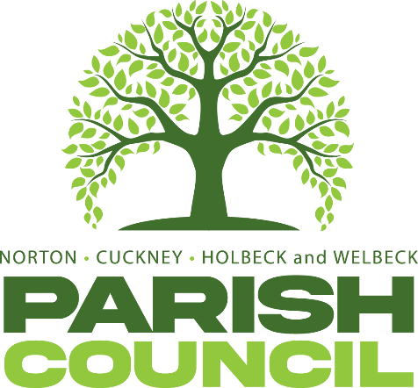

ANNUAL COUNCIL MEETING
Pursuant to Schedule 12 of the Local Government Act 1972, Councillors are hereby summoned to attend the Annual Parish Council Meeting of Norton, Cuckney, Holbeck, and Welbeck Parish Council to be held on Wednesday, 1st July 2026, at Harley’s Café, Welbeck at 7:00PM.
AGENDA
NCHW/32/26 | To receive apologies of absence
NCHW/33/26  NVHW/34/26 | To receive declarations of interest  To approve the minutes of the Full Council meeting held on Wednesday 4th February 2026.
NCHW/35/26 | To approve the minutes of the Full Council meeting held on Wednesday 6th May 2026.
NCHW/36/26  NCHW/37/26 | Questions from members of the public:  To allow a twenty-minute open forum (if required) for any members of the public to speak on matters affecting the Parish in accordance with section 3.e of the Council’s standing orders.  Members declaring a disclosable pecuniary interest who wish to make representation or give evidence under the Code of Conduct relating to agenda items shall do so at this stage.  To consider any items which should be taken in exclusion of the press and public.  If the Council decides to exclude the press and public it will be necessary to pass a resolution in the following terms: “That in view of the confidential nature of the business about to be transacted to consider a resolution to exclude the Press and Public from the meeting in accordance with the Public Bodies (Admission to Meetings) Act 1960, s1, in order to discuss the term.2 A reason must be stated.
NCHW/38/26 | Reports from the District and County Councillors and Nottinghamshire Police
NCHW/39/26 | To consider any relevant planning applications. None received.
NCHW/40/26 | To consider new business and receive updates about progress on existing resolutions:  - To discuss storage of street cleaning equipment and waste collected.  - To discuss Bassetlaw District Council’s new waste bin assessment scheme.  - To discuss the provision of a defibrillator in a more central location in Cuckney.  - To discuss request from County Councillor K Wright regarding Stop the Bleed work (STB).
NCHW/41/26  NCHW/42/26  NCHW/43/26 | Finances:  - Approval of Payments – April & May.  - Approval of Bank Reconciliation –April & May.  - Approval of Statement of Accounts – April & May  To receive updates on projects assigned to the Action Register and to consider the addition or removal of projects.  Items to be added (or carried forward) to the agenda of the next meeting.  Staffing Policies  Asset Register  Risk Register  Volunteer Policy  Wednesday 2nd September 2026 at Harley’s Café, Welbeck – Parish Council Meeting
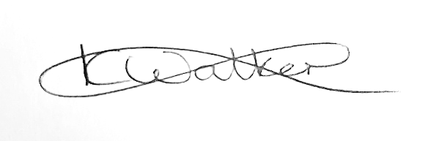
Mrs Kimberley Walker
Clerk & Proper Officer
Norton, Cuckney, Holbeck and Welbeck Parish Council
Ellenbrook, Cuckney, Nottinghamshire, NG20 9LX
Dated: Monday 22nd June 2026

