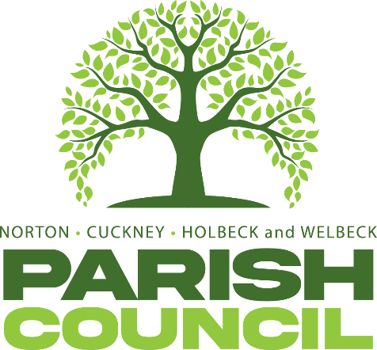

FULL COUNCIL MEETING
Pursuant to Schedule 12 of the Local Government Act 1972, Councillors are hereby summoned to attend the Meeting of Norton, Cuckney, Holbeck, and Welbeck Parish Council to be held on Wednesday, 7th January 2026, at Norton & Cuckney Village Hall at 7:00PM.
AGENDA
NCHW/91/25 | To receive apologies of absence
NCHW92/25 | To receive declarations of interest
NCHW/93/25 | To approve the minutes of the Full Council meeting held on Wednesday 5th November 2025.
NCHW/94/25 | Questions from members of the public:  To allow a twenty-minute open forum (if required) for any members of the public to speak on matters affecting the Parish in accordance with section 3.e of the Council’s standing orders.  Members declaring a disclosable pecuniary interest who wish to make representation or give evidence under the Code of Conduct relating to agenda items shall do so at this stage.
NCHW/95/25 | Reports from the District and County Councillors and Nottinghamshire Police
NCHW/96/25 | To consider any relevant planning applications.
NCHW/97/25 | To consider new business and receive updates about progress on existing resolutions:  - To receive annual play inspection report from The Play Inspection Company.  - To discuss ideas for Christmas 2026.  - To discuss email received from SAAA regarding digital submission AGAR.  - To discuss mitigation of risk to members of the public in the playing field.  - To discuss ownership of Steve’s memorial bench.
NCHW/98/25  NCHW/86/25 | To consider Councillor motions:  Councillor C Marples Proposes That the Parish Council allocate a payment of £1925 from the CiL Fund towards urgent repairs to the fabric of Norton and Cuckney Village Hall.  Councillor C Marples proposes that the Parish Council allocate a grant of £900 per year over a period of 3 years to pay for the annual contracted costs of Starlink internet services.  To receive updates on projects assigned to the Action Register and to consider the addition or removal of projects.
NCHW/87/25  NCHW/88/25  NCHW/89/25 | Finances:  - Approval of Payments – October, November and December.  - Approval of Bank Reconciliation – October, November and December.  - Approval of Budget.  - Approval of Precept.  Correspondence:  Items to be added (or carried forward) to the Agenda of the next meeting.
NCHW/90/25 | To confirm the date and time of the next meeting as Wednesday, 4th February 2026 at 7:00PM
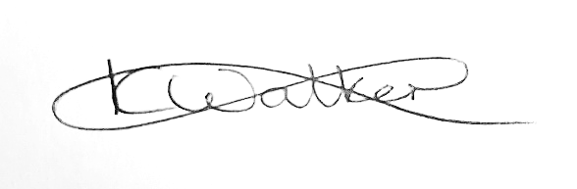
Mrs Kimberley Walker
Clerk & Proper Officer
Norton, Cuckney, Holbeck and Welbeck Parish Council
Ellenbrook, Cuckney, Nottinghamshire, NG20 9LX
Dated: Monday 22nd December 2025

