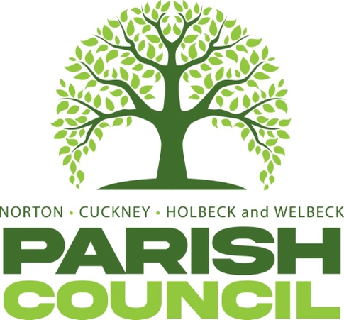

Minutes | 2nd April 2025 | 7.00 PM
Education Room, Harley Gallery.

In attendance

Cllr. Nancy Wright (Chairman) | Cllr. Kelvin Wright | Cllr Jackie Cuckson
Cllr Connor Marples | Cllr Sheila Brailsford | Mrs Kimberley Walker
Cllr Matthew Evans | Cllr Gemma Palmer
Cllr David Wall | Cllr James Palmer

NCHW/01/25 | To receive apologies of absence.
 | Apologies were received from Cllr. Stacy Cuckson.
NCHW/02/25 | To receive declarations of interest
 | None were declared.
NCHW/03/25 | To approve the minutes of the Full Council meeting held on Thursday 5th March 2025.
 | The acceptance of the minutes were proposed by Cllr. M Evans and seconded by Cllr. K Wright. These were agreed upon unanimously.
NCHW/04/25 | Questions from members of the public:
 | No members of the public were in attendance.
NCHW/05/02 | District and County Councillors Reports were proposed  District Cllr Charles Adam discussed (i) Warm homes insulation extended (ii) UKSBS funding renewed (iii) no update on water issues.
NCHW/06/25
  To consider any relevant planning applications
  None received.
NCHW/07/25  NCHW/08/25  NCHW/09/25 | To consider new business and receive updates about progress on existing resolutions:  - To receive report from HR Committee.  - Storage of Parish Council equipment.  - To receive report regarding Parish Council grant in relation to village hall structural works.  To receive updates on projects assigned to the Action Register and to consider the addition or removal of projects.  Finances:  - Approval of Payments.  It was proposed by Cllr. M. Evans and seconded by Cllr. J. Palmer that the payments be approved. This was agreed unanimously.  - Approval of Bank Reconciliation.  It was proposed by Cllr. M. Evans and seconded by Cllr. J. Palmer that the payments be approved. This was agreed unanimously.
NCHW/10/25 | Correspondence.  None received.
NHW/11/25 | Items to be added (or carried forward) to the Agenda of the next meeting.  Job role for Lengthsman position.  Bench or plaque in memory of S Pemberton  Update on post of Clerk  Feedback on D Canney play park
NCHW/127/24 | To confirm the date and time of the next meeting as Wednesday 7th May 2025 at 7:00PM

The meeting was closed by the Chairman at 20:29

Chairman’s signature _________________________ | Date ____________________

