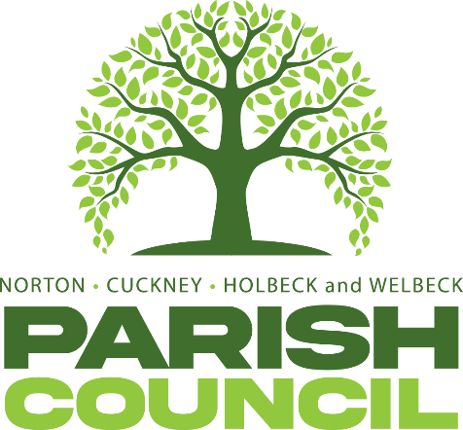

FULL COUNCIL MEETING
Pursuant to Schedule 12 of the Local Government Act 1972, Councillors are hereby summoned to attend the next ordinary meeting of Norton, Cuckney, Holbeck, and Welbeck Parish Council to be held on Wednesday, 2nd April 2025, at the Education Room, Harley Gallery at 7:00PM.

Mrs. Kimberley Walker
Locum Clerk & Responsible Financial Officer
DATED: THURSDAY 24th March 2025

AGENDA
NCHW/01/25 | To receive apologies of absence.
NCHW/02/25 | To receive declarations of interest.
NCHW/03/25 | To approve the minutes of the Full Council meeting held on Thursday, 9th January 2025.
NCHW/04/25 | Questions from members of the public:  To allow a twenty-minute open forum (if required) for any members of the public to speak on matters affecting the Parish in accordance with section 3.e of the Council’s standing orders.  Members declaring a disclosable pecuniary interest who wish to make representation or give evidence under the Code of Conduct relating to agenda items shall do so at this stage.
NCHW/05/25 | Reports from the District & County Councillors and Nottinghamshire Police
NCHW/06/25 | To consider any relevant planning applications
NCHW/07/25 | To consider new business and receive updates about progress on existing resolutions:  - To receive report from HR Committee.  - Storage of Parish Council equipment.  - To receive report regarding Parish Council grant in relation to village hall structural works.
NCHW/08/25 | To receive updates on projects assigned to the Action Register and to consider the addition or removal of projects.
NCHW/09/25 | Finances:  - Approval of Payments Statements  - Approval of Bank Reconciliation
NCHW/10/25 | Correspondence: None
NCHW/11/25 | Items to be added (or carried forward) to the Agenda of the next meeting.
NCHW/12/25 | To confirm the date and time of the next meeting as Wednesday, 7th May 2025 at 7:00PM

