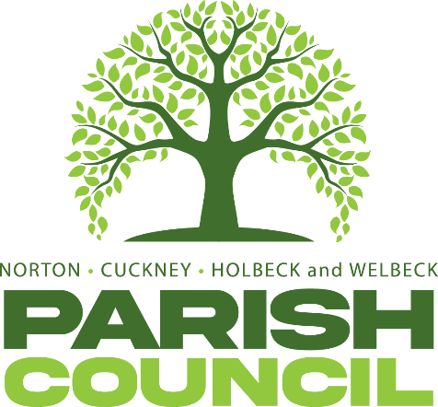

ANNUAL PARISH MEETING
Pursuant to the Local Government Act 1972, parishioners of Norton, Cuckney, Holbeck and Welbeck are hereby invited to attend the next annual meeting of Norton, Cuckney, Holbeck and Welbeck Parish to be held at Norton and Cuckney Village Hall, on Wenesday 7th May 2025 at 7:00 PM
AGENDA
NCHW/1/25 | Chairman’s welcome
NCHW/2/25 | To receive apologies of absence
NCHW/3/25 | To approve the minutes of the Annual Parish Meeting held on 09th May 2024
NCHW/4/25 | Item’s raised by Parishioners

Cllr Nancy Wright
Chairman of the Parish
Norton, Cuckney, Holbeck and Welbeck
287 Portland Road, Nether Langwith, Mansfield, Nottinghamshire, NG20 9EZ
Dated: Tuesday 25th April 2025

