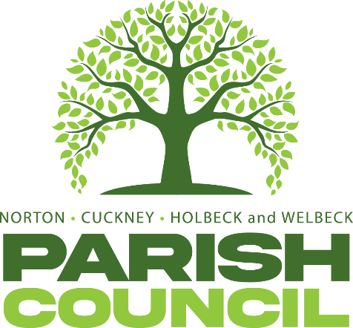

FULL COUNCIL MEETING
Pursuant to Schedule 12 of the Local Government Act 1972, Councillors are hereby summoned to attend the Annual General Meeting of Norton, Cuckney, Holbeck, and Welbeck Parish Council to be held on Tuesday, 07th May 2025, at Norton & Cuckney Village Hall at 7:15PM.
AGENDA
NCHW/13/25  NCHW/14/25  NCHW/15/25  NCHW/16/25 | Election of Chairman for the ensuing year 2025/2026  Election of Vice Chairman for the ensuing year 2025/2026  Sign Declarations of Acceptance of Office – Chairman and Vice Chairman  To receive apologies of absence
NCHW/17/25 | To receive declarations of interest
NCHW/18/25 | To approve the minutes of the Full Council meeting held on Tuesday, 2nd April 2025 (Page )
NCHW/19/25 | Questions from members of the public:  To allow a twenty-minute open forum (if required) for any members of the public to speak on matters affecting the Parish in accordance with section 3.e of the Council’s standing orders.  Members declaring a disclosable pecuniary interest who wish to make representation or give evidence under the Code of Conduct relating to agenda items shall do so at this stage.
NCHW/20/25 | Reports from the District and County Councillors and Nottinghamshire Police
NCHW/21/25 | To consider any relevant planning applications (page )
NCHW/22/25 | To consider new business and receive updates about progress on existing resolutions:  - To receive report from HR Committee.  - To discuss job role for lengthsman.  - To discuss memorial bench/plaque.  - To receive update on Clerk’s post.  - To receive feedback on play park  - To receive an update on meeting with Rev Gough regarding bridge issue.
NCHW/23/25 | To receive updates on projects assigned to the Action Register and to consider the addition or removal of projects.
NCHW/24/25 | Finances:  - Approval of Payments  - Approval of Bank Reconciliation  - Approval of Statement of Accounts  - Review of Asset Register  - Review of Risk Register
NCHW/25/25 | To review, amend, create and approve the Council’s core documents  - Council’s Standing Orders  - Council’s Code of Conduct  - Council’s Financial Regulations  - Council’s Complaints Procedure  - Council’s Equal Opportunities and Diversity  - Counci’s Privacy Policy  - Council’s Data Protection Policy
NCHW/26/25  NCHW/27/25 | Correspondence:  Elections of committees.
NCHW/28/25 | Items to be added (or carried forward) to the Agenda of the next meeting.
NCHW/29/25 | To confirm the date and time of the next meeting as Wednesday, 4th June 2024 at 7:00PM

Mrs Kimberley Walker
Locum Clerk & Proper Officer
Norton, Cuckney, Holbeck and Welbeck Parish Council
Ellenbrook, Cuckney, Nottinghamshire, NG20 9LX
Dated: Wednesday 30th April 2025

