

FULL COUNCIL MEETING

Pursuant to Schedule 12 of the Local Government Act 1972, Councillors are hereby
summoned to attend the next ordinary meeting of Norton, Cuckney, Holbeck, and Welbeck Parish Council to be held on Thursday, 11th July 2024, at Norton and Cuckney Village Hall at 7.00PM

AGENDA

NCHW/30/24 | To receive apologies of absence
NCHW/31/24 | To receive declarations of interest
NCHW/32/24 | To approve the minutes of the Full Council meeting held on Thursday, 13th June 2024
NCHW/33/24 | Questions from members of the public:  To allow a twenty-minute open forum (if required) for any members of the public to speak on matters affecting the Parish in accordance with section 3.e of the Council’s standing orders.  Members declaring a disclosable pecuniary interest who wish to make representation or give evidence under the Code of Conduct relating to agenda items shall do so at this stage.
NCHW/34/24 | Reports from the District and County Councillors and Nottinghamshire Police
NCHW/35/24 | Report from representative Trustees for the Norton and Cuckney Village Hall Charity (charity no. 1041895)
NCHW/36/24 | To consider any relevant planning applications
NCHW/37/24 | To consider new business and receive updates about progress on existing resolutions:  - Jubilee Community Garden – gardening contract  - Gate for Cuckney Play Park  - Norton Play Park Fencing
NCHW/38/24 | To receive updates on projects assigned to the Action Register and to consider the addition or removal of projects
NCHW/39/24 | Finances:  - Approval of Payments  - Approval of Bank Reconciliation
NCHW/40/24 | Correspondence:
NCHW/41/24 | Items to be added (or carried forward) to the agenda of the next meeting
NCHW/42/24 | To confirm the date and time of the next meeting as Thursday, 12th September 2024 at 7:00PM

Cllr Matthew Evans
Acting Clerk & Proper Officer
Norton, Cuckney, Holbeck and Welbeck Parish Council

287 Portland Road, Nether Langwith, Mansfield, Nottinghamshire, NG20 9EZ

NCHW/37/24 (c) Norton Play Park Fencing

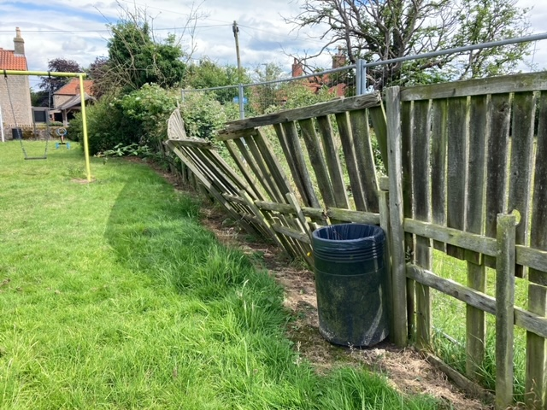

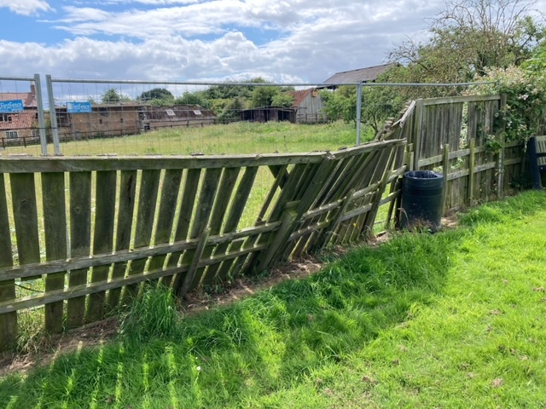

NCHW/38/24 – ACTION REGISTER – CAPITAL PROJECTS COMMITTEE

SENSITIVE – PLEASE DO NOT DISTRIBUTE

The Bridge from Cuckney Play Park to the school

The bridge was installed in approximately 1983 by a group of school governors.

Ownership and responsibility

The county council has confirmed that it is not on the school’s land and that their boundary ends at the end of the playground. The Parish Council’s boundary ends with the gate to the bridge.

School does not accept liability for the bridge and says that they have no riparian responsibility for it (confirmed by Natalie Hodgson, case worker in this matter at Nottinghamshire County Council) but is the sole user and has been for 40 years. The school must have access to the playing field to maintain their OFSTED rating – currently GOOD. The school has alternative access to the playing field via Creswell Road or by walking round the dam.

Although the county council takes no responsibility for the bridge, it has confirmed that the school wishes to continue to use it.

Action by the Parish Council (up to 28th June 2024)

The bridge has been accessible from the playing field because although there is a gate, it has not been locked. The sides of the bridge are somewhat rickety. Therefore, to meet its safe-guarding requirements, the Parish Council voted at its meeting in June 2024 to close the gate to the bridge from the playing field side. Cllr J Palmer was tasked to write to the Headmistress, Lisa Crossland to inform her of the Parish Council’s decision.

In response to the Head’s complaints about this decision, a compromise has been put in place for the mean-time which means that the gate is locked after school breaks by the school. Both the school and Parish Council have the combination. A ‘No Public Access’ sign has been put on the Playing Field side of the gate.

Cllr Palmer also agreed to appraise the Parish Council on the state of the gate with a view to replacing it.

Meeting with Welbeck

On Friday 28th June, Cllrs Palmer and Wright had a meeting with David Cannie and Darren Ridout from Welbeck.

The immediate response was that if the school will not take responsibility for the bridge, then the bridge should be removed and that the view of those Welbeck representatives in the meeting were that the Parish Council should change the combination on the padlock as soon as the school breaks up for the summer.

There was discussion about companies that make bridges (advertising in the Clerk and Council Direct magazine) and that this would be a relatively low-cost solution. Cllr Wright would provide these details to Welbeck.

After further conversation, Darren Ridout proposed that (following some research on costings) a new bridge could be purchased and installed by Welbeck. The costs of this could be met from the Section 106 monies. The school would accept liability for the new bridge. If this solution is not accepted by the school, then Welbeck will remove the bridge. The Parente family will be updated regarding the matter.

The Parish Council will await a decision regarding the new bridge decision the extant one before looking into replacing the fencing or any gates.

To facilitate access by the general public and for the use by the school, the Parish Council will get a quote to install steps on the slope. Cllr J Palmer will contact Dean (Welbeck’s preferred contractor) who has done all previous work on fencing in the play park) to get a price for this work.

Lease

The school pays nothing for use of the playing field and there is no formal agreement in place. The grass is cut by the County Council.

Welbeck has asked for a formal agreement to be discussed with the school as a pre-requisite for granting a new lease to the Parish Council for the playing field. The school will be charged to sub-let the field for its use during school hours. Welbeck have made it clear that it expects the Parish Council not to make a profit from this arrangement.

To allow the Parish Council to proceed with its own plans whilst the lease negotiations are going on, David Cannie agreed to produce a Heads of Terms document and write supporting letter to allow for capital funding applications. Cllr J Palmer will check with NALC as to whether there are any issues with the Parish Council proceeding with fundraising on this basis.

David Cannie will get a quote for legal costs of drawing up a 25-year lease. He suggested that Welbeck and the Parish Council share the costs of this legal work (approx. £2000 for each party). The Parish Council will need to clarify if that includes the sub-lease to the school. Welbeck will require named parish Councillors on the lease (The Parish Council need to seek advice from NALC on this).

David Cannie also raised concerns about the school’s use of the play park equipment,
especially if the children are using play equipment with minimal supervision. The Parish Council will need to see copies of the school’s risk assessment regarding this matter.

NCHW/39/24 (a) Budget Report

NCHW/39/24 (a) Reconciliation

NCHW/40/24 – CORRESPONDENCE

EMAIL RECEIVED 5 JULY 2024

Dear Nancy
The members of St Mary’s and St Winifred’s Joint PCC have asked me to write to the council to express their grateful thanks for the new commemorative bench which they have kindly donated to St Winifred’s Church.
The photograph in the latest edition of the Community newsletter shows how well the new seat looks and it will be much appreciated by visitors to the churchyard.
Thankyou once again for this generous donation.
On behalf of the joint PCC’s of St Mary’s, Norton and St Winifred’s, Holbeck Woodhouse
Rev Dave Gough and Vanessa Morris

